Lab Project

A CMO/CRO Project Database

Stephanie Barclay
DBST651, Fall 2011

Submitted To

Graduate School
University of Maryland University College

Date:
Due 11/17/13

Table of Contents:

Statement of Work……………………………………………………………………………3
Entity Relationship Diagram…………………………………………………………….4
Data Definition Language/Data Manipulation Language………………..6
Select Statements…………………………………………………………………………….24
Log File………………………………………………………………………………………………29

Statement of Work (SOW)

Deliverable 1
Stephanie Barclay
DBST651, Fall 2013

Overview:
I will create a database to keep track of a laboratory’s equipment SOPs, chemicals and media components, cell lines and plasmids, batch records, and scientists.
Purpose and Objective:
The database will enable the laboratory to store the information it needs to prepare and perform production runs. The information includes production dates, client-specified requirements, categories of media (i.e. type, non-animal source, etc.), GMP (good manufacturing practices), project-specific information, and also the appropriate cell lines. The information stored in this database will allow the laboratory to create media based on reagents in stock, provide information to schedule manpower for production runs, and ensure proper cell line, etc.
Diagram Tool:
ER Assistant (version 2.10) on a Lenovo ThinkPad running Windows 7
Database:
Oracle 11g Using NOVA
Hardware and Software:
UMUC server system Nova (Sun Enterprise T2000) connected through Putty Release 0.61.
My operating system is Windows 7.
Editiors/Development tool(s) are: MS Notepad and Oracle (iSQLPLUS or SQL*PLUS).
DDL and DML:
SQL (Structured Query Language) will be used for the DDL and DML. For my DDL scripts, I will use SQL to translate the information captured in my ER diagram (created in ER Assistant) into database table creation scripts. For my DML scripts, I will use SQL to insert rows of data into my database tables.

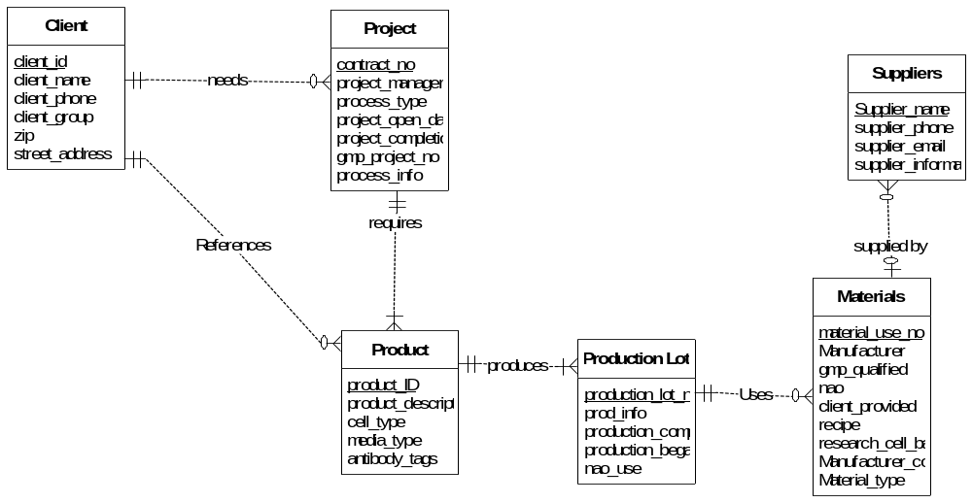

ERD
Client information will contain all a client’s relevant information: name, group, phone, address. This would imply that there could exist multiple groups within a single company. Therefore, a client ID must be generated for each client/group combination to serve as a primary key. Each client/group can solicit multiple projects (contracts).

Each project contains the product information—usually a protein or lipopolysaccharide (LPS)—for the project; the type of process to be performed such as whether it will be process development or production and whether or not it is a GMP-type production; the specific GMP project identifier assigned to all GMP projects to protect privacy; project manager; project start and end dates; and the project number as the primary key.

A project may require multiple products. For example, a vaccine process development project could contain a LPS product, a protein product, and a final conjugated product. Product description (LPS or protein etc), cell types to be grown (eg E.coli or Vibrio cholerae), and if specified media type and antibody tags are defined within the product entity.

Each project will likely contain multiple production lots. For example, a simple protein production project could require the plasmid transformation into E.coli, the generation of glycerol stocks or research cell bank, and production of raw protein via cellular induction, and conjugation and purification of final protein product. Note: downstream conjugation and purification procedures are not the purview of this database project. Production lot number as primary key, production type (shake flask, bioreactor, glycerol stock production, etc.), cell and media type, whether or not the media is from a non-animal source, and production start and finish dates are part of this entity.

The Materials entity contains basic information to aid in ordering more of a specific chemical, media, and competent cell type. Media type and cell type are included as a single entity to reduce the number of entities. Since this creates redundancies in the table, the table entries will be automatically assigned a numerical primary key. Whether or not both cells and media are GMP grade is included in entities. Note: GMP (good manufacturing practices) imply more stringent requirements and must be cleared by QA/QC. Having such information directly available would be advantageous.

The Supplier entity will include contact information for qualified suppliers. This table will contain supplier name, phone number, sales representative, etc.

DDL (Data Definition Language)

REM ******************************************************************
REM File: SBarclayDBST_LabProjectPart3.txt
REM Description: Used for creating the objects and loading data
REM into the SBARCLAY schema
REM Created: S Barclay October 18, 2013
REM Modified November 9, 2013
REM Version: 1.7
REM ******************************************************************
REM ******************************************************************
REM Section 8
REM Drop objects so that the program can be run again for verification
REM that code works
SET ECHO OFF

PROMPT Dropping tables.
DROP TABLE PROJECT;
DROP TABLE CLIENT;
DROP TABLE PRODUCT;
DROP TABLE PRODUCTION_LOT;
DROP TABLE MATERIALS;
DROP TABLE SUPPLIERS;
PROMPT Dropping trigger sequence.
DROP SEQUENCE material_use_seq;
PROMPT Dropping views.
DROP VIEW client_contact;
DROP VIEW supplier_summary;
SET ECHO ON
REM*****************************************************************
REM*****************************************************************
REM Section 1
REM Create Tables
REM ******************************************************************
REM Section 1.a
PROMPT Creating Table 'CLIENT'
CREATE TABLE CLIENT
(CLIENT_ID NUMBER(8,0) NOT NULL
,CLIENT_NAME VARCHAR2(100)
,CLIENT_GROUP VARCHAR2(25)
,STREET_ADDRESS VARCHAR2(50)
,ZIP VARCHAR2(5)
,PHONE VARCHAR2(15)
)
/
COMMENT ON TABLE CLIENT IS 'Client information for project management uses.'
/

COMMENT ON COLUMN CLIENT.CLIENT_ID IS 'The unique ID for an client.'
/

COMMENT ON COLUMN CLIENT.CLIENT_NAME IS 'Organization name of client, such as Merck, Eli Lilly etc'
/

COMMENT ON COLUMN CLIENT.CLIENT_GROUP IS 'Specific group within the client organization such as Phoenix lab.'
/

COMMENT ON COLUMN CLIENT.STREET_ADDRESS IS 'The clients street address.'
/

COMMENT ON COLUMN CLIENT.ZIP IS 'The postal zip code for this client.'
/

COMMENT ON COLUMN CLIENT.PHONE IS 'The phone number for this client including area code.'
/
REM ******************************************************************
REM Section 1.b
PROMPT Creating Table 'PROJECT'
CREATE TABLE PROJECT
(CONTRACT_NO NUMBER(8,0) NOT NULL
,CLIENT_ID NUMBER(8,0) NOT NULL
,PROJECT_MANAGER VARCHAR2(30)
,GMP_PROJECT_NO NUMBER(4) DEFAULT 0
,PROCESS_TYPE NUMBER(2) DEFAULT 0
,PROCESS_INFO VARCHAR2(2000)
,PROJECT_OPEN_DATE DATE
,PROJECT_COMPLETION_DATE DATE
)
/
COMMENT ON TABLE PROJECT IS 'The information relevant to each project.'
/
COMMENT ON COLUMN PROJECT.CONTRACT_NO IS 'The unique ID for the project.'
/
COMMENT ON COLUMN PROJECT.PROJECT_MANAGER IS 'The manager in charge of this project.'
/
COMMENT ON COLUMN PROJECT. GMP_PROJECT_NO IS 'The number assigned to this gmp project. 0 if na.'
/
COMMENT ON COLUMN PROJECT.GMP_PROJECT_NO IS 'The code which identifies a GMP process.'
/
COMMENT ON COLUMN PROJECT.PROCESS_TYPE IS 'The number assigned to different process types. Upstream 1x, downstream 2x, analytics 3x, viral 4x, production x1, process development x2, etc. See documentation for full list. For undefined processes enter 99.'
/
COMMENT ON COLUMN PROJECT.PROCESS_INFO IS 'Information describing process for users.'
/
COMMENT ON COLUMN PROJECT.PROJECT_OPEN_DATE IS 'Date that project is initiated.'
/
COMMENT ON COLUMN PROJECT.PROJECT_COMPLETION_DATE IS 'Date project is required to be completed.'
/
REM ******************************************************************
REM Section 1.c
PROMPT Creating Table 'PRODUCT'
CREATE TABLE PRODUCT
(PRODUCT_ID NUMBER(8,0) NOT NULL
,CONTRACT_NO NUMBER(8,0) NOT NULL
,CELL_TYPE VARCHAR2(50)
,MEDIA_TYPE VARCHAR2(30)
,ANTIBODY_TAGS VARCHAR2(30)
,PRODUCT_DESCRIPTION VARCHAR2(500)
)
/
COMMENT ON TABLE PRODUCT IS 'Specific information for a particular product.'
/
COMMENT ON COLUMN PRODUCT.PRODUCT_ID IS 'The unique code which identifies a specific product.'
/
COMMENT ON COLUMN PRODUCT.CELL_TYPE IS 'Client-specified cell type for the project.'
/
COMMENT ON COLUMN PRODUCT.MEDIA_TYPE IS 'Client-specified media type for the project.'
/
COMMENT ON COLUMN PRODUCT.ANTIBODY_TAGS IS 'Antibody tags on protein product.'
/
COMMENT ON COLUMN PRODUCT.PRODUCT_DESCRIPTION IS 'Short description of the project.'
/
REM ******************************************************************
REM Section 1.d
PROMPT Creating Table 'PRODUCTION_LOT'
CREATE TABLE PRODUCTION_LOT
(PROD_LOT_NO VARCHAR2(10) NOT NULL
,PRODUCT_ID NUMBER(8,0) NOT NULL
,PROD_INFO VARCHAR2(500)
,PROD_BEGAN DATE
,PROD_COMPLETED DATE
,NAO_USE VARCHAR2(1) DEFAULT 0
)
/

COMMENT ON TABLE PRODUCTION_LOT IS 'Contains particulars of a single production lot.'
/
COMMENT ON COLUMN PRODUCTION_LOT.PROD_LOT_NO IS 'The unique set of numbers and symbols that are assigned to a production lot (11-13-213, etc.).'
/
COMMENT ON COLUMN PRODUCTION_LOT. PRODUCT_ID IS 'For foreign key from product table.'
/
COMMENT ON COLUMN PRODUCTION_LOT.PROD_INFO IS 'Describes the type of production (eg continuous fed-batch in superbroth).'
/
COMMENT ON COLUMN PRODUCTION_LOT.PROD_BEGAN IS 'indicates date the production lot began.'
/
COMMENT ON COLUMN PRODUCTION_LOT.PROD_COMPLETED IS 'Date production lot completed.'
/
COMMENT ON COLUMN PRODUCTION_LOT.NAO_USE IS 'Indicates whether or not the process used animal free components. 1, yes. 0,no.'
/
REM ******************************************************************
REM Section 1.e
PROMPT Creating Table 'MATERIALS'
CREATE TABLE MATERIALS
(MATERIAL_USE_NO NUMBER(10) NOT NULL
,MATERIAL_NAME VARCHAR2(50) NOT NULL
,PROD_LOT_NO VARCHAR2(10) NOT NULL
,MANUFACTURER VARCHAR2(50)
,MANUFACTURER_CODE VARCHAR2(100)
,SUPPLIER_NAME VARCHAR2(50) NOT NULL
,MATERIAL_TYPE VARCHAR2(50)
,GMP_QUALIFIED VARCHAR2(5)
,NAO VARCHAR2(10)
,CLIENT_PROVIDED VARCHAR2(3)
,RECIPE VARCHAR2(2000)
,RESEARCH_CELL_BANK VARCHAR2(30)
)
/
COMMENT ON TABLE MATERIALS IS 'Information on materials used in production. Ideally, this table should be broken down into multiple, however it was suggested when I got my ERD approved that I combine the broken down versions into one table. Therefore the roughly combined table is constructed as above. I dont like it, but this is what it resolved to.'
/
COMMENT ON COLUMN MATERIALS.MATERIAL_USE_NO IS 'An automatically generated primary key. This allows for duplicate values in media and cell type .'
/
COMMENT ON COLUMN MATERIALS.PROD_LOT_NO IS 'production lot number for foreign key.'
/
COMMENT ON COLUMN MATERIALS.MANUFACTURER IS 'material manufacturer if different from supplier.'
/
COMMENT ON COLUMN MATERIALS.MANUFACTURER_CODE IS 'The identification code assigned to a product by its manufacturer.'
/
COMMENT ON COLUMN MATERIALS.SUPPLIER_NAME IS 'name of the supplier of this material, for foreign key.'
/
COMMENT ON COLUMN MATERIALS.MATERIAL_NAME IS 'The specific name of the material to be used.'
/
COMMENT ON COLUMN MATERIALS.MATERIAL_TYPE IS 'Cell, media, or supplement.'
/
COMMENT ON COLUMN MATERIALS.GMP_QUALIFIED IS 'Indicates whether or not a material is qualified for GMP (yes, no, unknown).'
/
COMMENT ON COLUMN MATERIALS.NAO IS 'Indicates whether or not a material is animal origin or from non-animal source (yes, no, or unknown).'
/
COMMENT ON COLUMN MATERIALS.CLIENT_PROVIDED IS 'Indicates if the material is specifically provided by the client.'
/
COMMENT ON COLUMN MATERIALS.RECIPE IS 'Contains the recipe for specific media or supplement formulation or use.'
/
COMMENT ON COLUMN MATERIALS.RESEARCH_CELL_BANK IS 'Reference number of the specific research cell bank used, if applicable.'
/
REM ******************************************************************
REM Section 1.f
PROMPT Creating Table 'SUPPLIERS'
CREATE TABLE SUPPLIERS
(SUPPLIER_NAME VARCHAR2(50) NOT NULL
,SUPPLIER_EMAIL VARCHAR2(100)
,SUPPLIER_PHONE VARCHAR2(20)
,SUPPLY_INFORMATION VARCHAR(500)
,SALES_REP VARCHAR2(100)
)
/
COMMENT ON TABLE SUPPLIERS IS 'Information for an suppliers of particular materials.'
/
COMMENT ON COLUMN SUPPLIERS.SUPPLIER_NAME IS 'The individual supplier of the material.'
/
COMMENT ON COLUMN SUPPLIERS. SUPPLIER_EMAIL IS 'The email contact information of the supplier.'
/
COMMENT ON COLUMN SUPPLIERS.SUPPLIER_PHONE IS 'The contact phone number for the supplier.'
/
COMMENT ON COLUMN SUPPLIERS. SUPPLY_INFORMATION IS 'Specific information about the supplier including opinions on quality etc.'
/
COMMENT ON COLUMN SUPPLIERS.SALES_REP IS 'The name of the sales rep in charge of our account.'
/
REM Section 1 end
REM ******************************************************************
REM ******************************************************************
REM Section 2
REM Create foreign key indexes
-- sbarclay.ind

PROMPT Creating Index 'CLIENT_ID_FK_I'
CREATE INDEX CLIENT_ID_FK_I ON PROJECT (CLIENT_ID)
/

PROMPT Creating Index 'CONTRACT_NO_FK_I'
CREATE INDEX CONTRACT_NO_FK_I ON PRODUCT (CONTRACT_NO)
/

PROMPT Creating Index 'PRODUCT_ID_FK_I'
CREATE INDEX PRODUCT_ID_FK_I ON PRODUCTION_LOT (PRODUCT_ID)
/

PROMPT Creating Index 'PROD_LOT_NO_FK_I'
CREATE INDEX PROD_LOT_NO_FK_I ON MATERIALS (PROD_LOT_NO)
/

PROMPT Creating Index SUPPLIER_NAME_FK_I'
CREATE INDEX SUPPLIER_NAME_FK_I ON MATERIALS (SUPPLIER_NAME)
/
REM Section 2 end

REM ******************************************************************
REM ******************************************************************
REM Section 3
REM Create trigger for material use number
REM generates the primary key for table MATERIALS
PROMPT Creating Sequence 'MATERIAL_USE_SEQ'
CREATE SEQUENCE MATERIAL_USE_SEQ
INCREMENT BY 1
START WITH 1
NOMAXVALUE
MINVALUE 1
NOCYCLE
NOCACHE
/
CREATE OR REPLACE TRIGGER mat_use_no_trg_bir
BEFORE INSERT ON materials
FOR EACH ROW
BEGIN
IF :new.MATERIAL_USE_NO IS NULL THEN
SELECT material_use_seq.NEXTVAL
INTO :new.MATERIAL_USE_NO
FROM DUAL;
END IF;
END;
/
REM ******************************************************************
REM ******************************************************************
REM Section 4
REM Insert values into tables
REM ******************************************************************
REM Section 4.a
PROMPT inserting values into Client table
ALTER SESSION SET NLS_DATE_FORMAT = 'DD-MON-RR';
SET DEFINE OFF

INSERT INTO client VALUES (19960410,'Johnson & Johnson','Protein Sciences',' One Johnson & Johnson Plaza NEW BRUNSWICK NJ', '08933', '732-524-0400');
INSERT INTO client VALUES (19960411,'Pfizer','Viral Labs','20 Eastern Ave Beaumont TX ', '71904', '619-831-9090');
INSERT INTO client VALUES (19960412,'GlaxoSmithKline', 'NA','555 SuperFun Dr Nowhere NV ','33393', '903-293-5567');
INSERT INTO client VALUES (19960413,'Novartis','West Point','13 Bad Luck Lane Philadelphia PA ', '21343', '210-756-0410');
INSERT INTO client VALUES (19960414,'AstraZeneca','PreClinical Group','777 Too Bad So Sad Circle Albuquerque NM', '98787', '657-598-1114');
INSERT INTO client VALUES (19960415,'Merck & Co','Texas Group','21104 Sam Houston Ln Austin TX', '71898', '940-444-7889');
INSERT INTO client VALUES (19960421,'Merck & Co','New England Group','32 Bad Accent Block Boston MA', '00302', '209-465-7191');
INSERT INTO client VALUES (19960416,'Eli Lilly','Process Development',' 5909 One Day Dr Someplace IN', '66565', '700-784-9890');
INSERT INTO client VALUES (19960417,'Bristol-Myers Squibb','NA',' 2127 Bad Day Dr Minneapolis MN', '90302', '800-214-0499');
COMMIT;
REM ******************************************************************
REM Section 4.b
PROMPT inserting values into project table

INSERT INTO project VALUES (2013293,19960410,'R Montmorency',0,11 ,'Protein expression in Pichia pastoris', TO_DATE('20-FEB-2013','DD-MON-YYYY '), TO_DATE('13-MAR-2013','DD-MON-YYYY '));
INSERT INTO project VALUES (2013294,19960411,'L Valliere',0,30,'PCR', TO_DATE('30-JAN-2013','DD-MON-YYYY '), TO_DATE('14-FEB-2013','DD-MON-YYYY '));
INSERT INTO project VALUES (2013295,19960412,'R Montmorency',0,22,'Process development of downstream purification ', TO_DATE('18-MAR-2013','DD-MON-YYYY '), TO_DATE('18-JAN-2014','DD-MON-YYYY '));
INSERT INTO project VALUES (2013296,19960413,'Domo kun ',1546,11,'GMP protein production', TO_DATE('30-JUN-2013','DD-MON-YYYY '), TO_DATE('12-JUL-2015','DD-MON-YYYY '));
INSERT INTO project VALUES (2013297,19960414,'I Kurosaki',0,42,'Bacteriophage production in salmonella', TO_DATE('22-JUL-2013','DD-MON-YYYY '), TO_DATE('12-AUG-2013','DD-MON-YYYY '));
INSERT INTO project VALUES (2013298,19960415,'Domo kun ',0,12,'Process development of protein production in pseudomonas', TO_DATE('04-JUN-2014','DD-MON-YYYY '), TO_DATE('04-JUN-2015','DD-MON-YYYY '));
INSERT INTO project VALUES (2013299,19960416,'L Valliere',9090,11,'GMP protein production', TO_DATE('17-SEP-2013','DD-MON-YYYY '), TO_DATE('30-SEP-2015','DD-MON-YYYY '));
INSERT INTO project VALUES (2013230,19960417,'R Montmorency',0,21 ,'Downstream purification', TO_DATE('4-JAN-2014','DD-MON-YYYY '), TO_DATE('30-JAN-2014','DD-MON-YYYY '));
INSERT INTO project VALUES (2013231,19960421,'L Heartfilia',0,99,'plasmid prep ', TO_DATE('20-OCT-2013','DD-MON-YYYY '), TO_DATE('31-OCT-2013','DD-MON-YYYY '));
INSERT INTO project VALUES (2013232,1990421,'Z Roronoa ',0,41,'Production of bacteriophage in Ecoli', TO_DATE('11-NOV-2013','DD-MON-YYYY '), TO_DATE('31-DEC-2013','DD-MON-YYYY '));
INSERT INTO project VALUES (2013233,1990415,'R Kuchiki',0,30,'Mass Spec analysis', TO_DATE('30-JUL-2013','DD-MON-YYYY '), TO_DATE('07-SEP-2013','DD-MON-YYYY '));
INSERT INTO project VALUES (2013234,1990413,'Domo kun ',0,11,'protein expression in Ecoli', TO_DATE('08-SEP-2013','DD-MON-YYYY '), TO_DATE('30-SEP-2013','DD-MON-YYYY '));
INSERT INTO project VALUES (2013235,1990415,'R Kuchiki ',0,10,'Staph aureus growth only', TO_DATE('07-MAR-2013','DD-MON-YYYY '), TO_DATE('14-MAR-2013','DD-MON-YYYY '));
INSERT INTO project VALUES (2013236,1990411,'MD Luffy',0,11 ,'protein expression in CHO ', TO_DATE('19-APR-2013','DD-MON-YYYY '), TO_DATE('1-JUL-2013','DD-MON-YYYY '));
INSERT INTO project VALUES (2013237,1990421,'L Heartfilia',8756,11,'GMP protein production', TO_DATE('01-JAN-2013','DD-MON-YYYY '), TO_DATE('22-DEC-2014','DD-MON-YYYY '));
INSERT INTO project VALUES (2013238,1990410,'L Valliere ',0,11,'LPS production in Vibrio sp', TO_DATE('03-OCT-2013','DD-MON-YYYY '), TO_DATE('30-JAN-2014','DD-MON-YYYY '));
INSERT INTO project VALUES (2013239,1990412,'R Kuchiki',0,11,'Production of tetanus toxin', TO_DATE('02-MAY-2013','DD-MON-YYYY '), TO_DATE('30-JUN-2013','DD-MON-YYYY '));
INSERT INTO project VALUES (2013400,1990421,'E Titania',0,11,'Production of p233465', TO_DATE('02-MAY-2013','DD-MON-YYYY '), TO_DATE('30-JUN-2013','DD-MON-YYYY '));
INSERT INTO project VALUES (2013401,1990421,'E Titania',0,11,'Production of p233499', TO_DATE('30-JUN-2013','DD-MON-YYYY '), TO_DATE('30-JUL-2013','DD-MON-YYYY '));
INSERT INTO project VALUES (2013402,1990421,'E Titania',0,11,'Production of p233408', TO_DATE('30-JUL-2013','DD-MON-YYYY '), TO_DATE('30-AUG-2013','DD-MON-YYYY '));
INSERT INTO project VALUES (2013403,1990421,'E Titania',0,11,'Production of p233456', TO_DATE('30-AUG-2013','DD-MON-YYYY '), TO_DATE('30-SEP-2013','DD-MON-YYYY '));
INSERT INTO project VALUES (2013404,1990421,'E Titania',0,11,'Production of p233412', TO_DATE('30-SEP-2013','DD-MON-YYYY '), TO_DATE('30-OCT-2013','DD-MON-YYYY '));

COMMIT;
REM ******************************************************************
REM Section 4.c

PROMPT inserting values into product table
INSERT INTO product VALUES (87560011,2013237,'E.coli BLR','Superbroth',NULL, 'IPTG-induced 30kDa protein');
INSERT INTO product VALUES (15460011,2013296,'E.coli BLR','LB',NULL, 'IPTG-induced 57kDa protein');
INSERT INTO product VALUES (90900011,2013299,'E.coli BLR','TB',NULL, 'IPTG-induced 150kDa protein');

INSERT INTO product VALUES (11111111,2013293,'Pichia pastoris','CDM', '6xHis', NULL);
INSERT INTO product VALUES (11111112,2013294,NULL,NULL,NULL, 'PCR dna amplification');
INSERT INTO product VALUES (11111113,2013231,'E.coli BL21 DE3','LB', NULL, 'Miniprep of plasmid WT1398');
INSERT INTO product VALUES (20132301,2013230,'E.coli BL21 DE3 Star',NULL, NULL, '90kDa protein');
INSERT INTO product VALUES (20132991,2013299,'E.coli BLR','TB', 'NA', 'IPTG-induced 150kDa protein');
INSERT INTO product VALUES (11111116,2013235,'Staphlococcus aureus','TB',NULL, 'Gowth only');
INSERT INTO product VALUES (11111117,2013234,'E.coli BL31 DE3 pLysS','CDM', '6xHis', 'IPTG-induced 18kDa protein');
INSERT INTO product VALUES (11111118,2013232,'E.coli BL21 DE3','LB', 'NA', 'bacteriophage MT322555');
INSERT INTO product VALUES (11111119,2013297,'Salmonella','CDM',NULL, '100kDa secreted protein');
INSERT INTO product VALUES (11111120,2013238,'Vibrio cholerae','CDM',NULL, 'Lipopolysaccharide production');
INSERT INTO product VALUES (11111121,2013239,'Clostridium tetani','CDM',NULL, '25kDa protein');
INSERT INTO product VALUES (11111122,2013295,'E.coli',NULL,NULL, '50kDa protein');
INSERT INTO product VALUES (11111123,2013236,'CHO','Serum-free media', 'FLAG', '33kDa protein');
INSERT INTO product VALUES (11111124,2013236,'CHO','Serum-free media', 'FLAG', '67kDa protein');
INSERT INTO product VALUES (11111125,2013298,'Pseudomonas fluorescens',NULL, '6xHis', '67kDa protein');
INSERT INTO product VALUES (11111126,2013298, 'Pseudomonas fluorescens',NULL, 'GST', '67kDa protein');
INSERT INTO product VALUES (20144001,2013400,'E.coli Bl21 DE3', '4xLB', 'Tau', 'p233465 is a 65kDa tau protein');
INSERT INTO product VALUES (20134011,2013401,'E.coli Bl21 DE3', 'LB', ' Tau', 'p233499 is a 99kDa tau protein');
INSERT INTO product VALUES (20134021,2013402,'E.coli Bl21 DE3', '4xLB', ' Tau', 'p233408 is a 108kDa tau protein');
INSERT INTO product VALUES (20134031,2013403,'E.coli Bl21 DE3', 'LB', ' Tau ', 'p233456 is a 56kDa tau protein');
INSERT INTO product VALUES (20132041,2013404,'E.coli BLR', '4xLB', ' Tau ', 'p233412 is a 12kDa tau protein');

COMMIT;
REM ******************************************************************
REM Section 4.d
PROMPT inserting values into production lot table
INSERT INTO production_lot VALUES ('01-13-101',87560011,NULL,TO_DATE('10-JUN-2013','DD-MON-YYYY'),TO_DATE('15-JUN-2013','DD-MON-YYYY'),1);
INSERT INTO production_lot VALUES ('01-13-102',87560011,NULL,TO_DATE('28-AUG-2013','DD-MON-YYYY'),TO_DATE('02-SEP-2013','DD-MON-YYYY'),1);
INSERT INTO production_lot VALUES ('01-13-103',15460011,NULL,TO_DATE('14-OCT-2013','DD-MON-YYYY'),TO_DATE('29-OCT-2013','DD-MON-YYYY'),1);
INSERT INTO production_lot VALUES ('01-13-104',11111111,NULL,TO_DATE('28-FEB-2013','DD-MON-YYYY'),TO_DATE('9-MAR-2013','DD-MON-YYYY'),0);
INSERT INTO production_lot VALUES ('03-13-101',11111112,NULL,TO_DATE('02-FEB-2013','DD-MON-YYYY'),TO_DATE('04-FEB-2013','DD-MON-YYYY'),0);
INSERT INTO production_lot VALUES ('01-13-105',11111113,NULL,TO_DATE('22-OCT-2013','DD-MON-YYYY'),TO_DATE('24-OCT-2013','DD-MON-YYYY'),0);
INSERT INTO production_lot VALUES ('01-13-106',11111116,NULL,TO_DATE('10-MAR-2013','DD-MON-YYYY'),TO_DATE('12-MAR-2013','DD-MON-YYYY'),0);
INSERT INTO production_lot VALUES ('01-13-107',11111117,NULL,TO_DATE('13-SEP-2013','DD-MON-YYYY'),TO_DATE('22-SEP-2013','DD-MON-YYYY'),0);
INSERT INTO production_lot VALUES ('01-13-108',11111119,NULL,TO_DATE('25-JUL-2013','DD-MON-YYYY'),TO_DATE('05-JUL-2013','DD-MON-YYYY'),0);
INSERT INTO production_lot VALUES ('01-13-109',11111120,NULL,TO_DATE('01-NOV-2013','DD-MON-YYYY'),TO_DATE('07-NOV-2013','DD-MON-YYYY'),0);
INSERT INTO production_lot VALUES ('01-13-110',11111121,NULL,TO_DATE('11-MAY-2013','DD-MON-YYYY'),TO_DATE('17-MAY-2013','DD-MON-YYYY'),0);
INSERT INTO production_lot VALUES ('01-13-111',11111122, '15L fed batch in superbroth',TO_DATE('06-MAY-2013','DD-MON-YYYY'),TO_DATE('08-MAY-2013','DD-MON-YYYY'),0);
INSERT INTO production_lot VALUES ('01-13-112', 11111122,'15L fed batch in NAO-superbroth',TO_DATE('15-MAY-2013','DD-MON-YYYY'),TO_DATE('17-MAY-2013','DD-MON-YYYY'),1);
INSERT INTO production_lot VALUES ('01-13-113', 11111122, '50L fed batch in NAO-superbroth',TO_DATE('01-JUN-2013','DD-MON-YYYY'),TO_DATE('05-JUN-2013','DD-MON-YYYY'),1);
INSERT INTO production_lot VALUES ('01-13-114',11111122, '15L fed batch in TB',TO_DATE('16-JUN-2013','DD-MON-YYYY'),TO_DATE('17-JUN-2013','DD-MON-YYYY'),0);
INSERT INTO production_lot VALUES ('01-13-115', 11111122,'15L fed batch in NAO-TB',TO_DATE('20-JUL-2013','DD-MON-YYYY'),TO_DATE('27-JULY-2013','DD-MON-YYYY'),1);
INSERT INTO production_lot VALUES ('01-13-116', 11111122, '50L fed batch in NAO-TB',TO_DATE('09-AUG-2013','DD-MON-YYYY'),TO_DATE('12-AUG-2013','DD-MON-YYYY'),1);
INSERT INTO production_lot VALUES ('01-13-117',11111123,NULL,TO_DATE('27-APR-2013','DD-MON-YYYY'),TO_DATE('06-MAY-2013','DD-MON-YYYY'),0);
INSERT INTO production_lot VALUES ('01-13-118',11111124,NULL,TO_DATE('15-JUN-2013','DD-MON-YYYY'),TO_DATE('27-JUN-2013','DD-MON-YYYY'),0);
INSERT INTO production_lot VALUES ('01-13-119',21134001,NULL,TO_DATE('15-MAY-2013','DD-MON-YYYY'),TO_DATE('20-MAY-2013','DD-MON-YYYY'),0);
INSERT INTO production_lot VALUES ('01-13-120', 21134011,NULL,TO_DATE('02-JUL-2013','DD-MON-YYYY'),TO_DATE('13-JUL-2013','DD-MON-YYYY'),0);
INSERT INTO production_lot VALUES ('01-13-121', 21134021,NULL,TO_DATE('21-AUG-2013','DD-MON-YYYY'),TO_DATE('26-AUG-2013','DD-MON-YYYY'),0);
INSERT INTO production_lot VALUES ('01-13-122', 21134031,NULL,TO_DATE('09-SEP-2013','DD-MON-YYYY'),TO_DATE('17-SEP-2013','DD-MON-YYYY'),0);
INSERT INTO production_lot VALUES ('01-13-123', 21134041,NULL,TO_DATE('18-OCT-2013','DD-MON-YYYY'),TO_DATE('21-OCT-2013','DD-MON-YYYY'),0);

COMMIT;
REM ******************************************************************
REM Section 4.e
PROMPT inserting values into materials table

INSERT INTO materials VALUES (material_use_seq.NEXTVAL,'Superbroth','01-13-101','TEKNOVA','S0115','VWR','media','YES', 'YES', NULL,NULL,NULL);
INSERT INTO materials VALUES (material_use_seq.NEXTVAL ,'Superbroth','01-13-102','SIGMA','C2309','VWR','media','YES', 'YES', NULL,NULL,NULL);
INSERT INTO materials VALUES (material_use_seq.NEXTVAL ,'LB','01-13-103','TEKNOVA','L3432','VWR','media','YES', 'YES', NULL,NULL,NULL);
INSERT INTO materials VALUES (material_use_seq.NEXTVAL ,'SUPERBROTH','01-13-111','TEKNOVA','S0110','VWR','media',NULL, NULL, NULL,NULL,NULL);
INSERT INTO materials VALUES (material_use_seq.NEXTVAL ,'Superbroth','01-13-113','TEKNOVA','S0115','VWR','media','YES', 'YES', NULL,NULL,NULL);
INSERT INTO materials VALUES (material_use_seq.NEXTVAL ,'Superbroth','01-13-112','TEKNOVA','S0115','TEKNOVA','media','YES', 'YES', NULL,NULL,NULL);
INSERT INTO materials VALUES (material_use_seq.NEXTVAL ,'TB','01-13-114','Sigma','TB9901','Sigma','media',NULL,NULL, NULL,NULL,NULL);
INSERT INTO materials VALUES (material_use_seq.NEXTVAL ,'TB','01-13-115','JTBAKER','TB9003','VWR','media', 'YES', 'YES', NULL,NULL,NULL);
INSERT INTO materials VALUES (material_use_seq.NEXTVAL ,'TB','01-13-116','JTBAKER','TB9003','VWR','media', 'YES', 'YES', NULL,NULL,NULL);
INSERT INTO materials VALUES (material_use_seq.NEXTVAL ,'LB','01-13-119','JTBAKER','LB9003','JT BAKER','media', 'YES', 'YES', NULL,NULL,NULL);
INSERT INTO materials VALUES (material_use_seq.NEXTVAL ,'LB','01-13-120','JTBAKER','LB9003','JT BAKER','media', 'YES', 'YES', NULL,NULL,NULL);
INSERT INTO materials VALUES (material_use_seq.NEXTVAL ,'LB','01-13-121','JTBAKER','LB9003','JT BAKER','media', 'YES', 'YES', NULL,NULL,NULL);
INSERT INTO materials VALUES (material_use_seq.NEXTVAL ,'LB','01-13-122','JTBAKER','LB9003','JT BAKER','media', 'YES', 'YES', NULL,NULL,NULL);
INSERT INTO materials VALUES (material_use_seq.NEXTVAL ,'LB','01-13-123','JTBAKER','LB9003','JT BAKER','media', 'YES', 'YES', NULL,NULL,NULL);
INSERT INTO materials VALUES (material_use_seq.NEXTVAL ,' Tau antibody','01-13-119','EMD','TAU90103', 'CLIENT','primary antibody', 'YES', 'YES', 'YES',NULL,NULL);
INSERT INTO materials VALUES (material_use_seq.NEXTVAL ,' Tau antibody','01-13-120','EMD','TAU90103', 'CLIENT','primary antibody', 'YES', 'YES', 'YES',NULL,NULL);
INSERT INTO materials VALUES (material_use_seq.NEXTVAL ,' Tau antibody ','01-13-121','EMD','TAU90103', 'CLIENT','primary antibody', 'YES', 'YES', 'YES',NULL,NULL);
INSERT INTO materials VALUES (material_use_seq.NEXTVAL ,' Tau antibody ','01-13-122','EMD','TAU90103', 'CLIENT','primary antibody', 'YES', 'YES', 'YES',NULL,NULL);
INSERT INTO materials VALUES (material_use_seq.NEXTVAL ,' Tau antibody ','01-13-123','EMD','TAU90103', 'CLIENT','primary antibody', 'YES', 'YES', 'YES',NULL,NULL);
INSERT INTO materials VALUES (material_use_seq.NEXTVAL ,' E.coli BL21 DE3 ','01-13-122','BD','EC03', 'BD','host cell', NULL, 'YES',NULL,NULL,NULL);
INSERT INTO materials VALUES (material_use_seq.NEXTVAL ,' E.coli BL21 DE3 ','01-13-121','BD','EC03', 'BD','host cell', NULL, 'YES',NULL,NULL,NULL);
INSERT INTO materials VALUES (material_use_seq.NEXTVAL ,' E.coli BL21 DE3 ','01-13-120','BD','EC03', 'BD','host cell', NULL, 'YES',NULL,NULL,NULL);
INSERT INTO materials VALUES (material_use_seq.NEXTVAL ,' E.coli BL21 DE3 ','01-13-119','BD','EC03', 'BD','host cell', NULL, 'YES',NULL,NULL,NULL);
INSERT INTO materials VALUES (material_use_seq.NEXTVAL ,' E.coli BLR ','01-13-123','Macron','EC03', 'Macron','host cell', 'YES', 'YES',NULL,NULL,NULL);

COMMIT;
REM ******************************************************************
REM Section 4.f
PROMPT inserting values into suppliers table
REM Note that not all established suppliers have current projects
INSERT INTO suppliers VALUES ('VWR','infovwr@vwr.com','800-234-9990', 'Difficult to get quotes but good prices', 'Virginia Price');
INSERT INTO suppliers VALUES ('Sigma','infosigma@sigmaaldrich.com','800-266-3454', 'quality media components', 'Katherine Webster');
INSERT INTO suppliers VALUES ('Teknova','contactus@teknova.com','800-432-9765', 'Many NAO products', 'Bill Maelstrom');
INSERT INTO suppliers VALUES ('JT Baker','bakerbums@jtbakes.com','800-090-8875',NULL, 'Bill Nye');
INSERT INTO suppliers VALUES ('Macron','contact@macronchemicals.com','410-888-7777',NULL, 'Flash Gordon');
INSERT INTO suppliers VALUES ('Mallinkrodt','mallinkrodt@mallink.us.com','888-444-9999',NULL, 'Hulk Smash');
INSERT INTO suppliers VALUES ('BD','orders@bd.com','897-1312-5564',NULL, 'Doctor Bob');
INSERT INTO suppliers VALUES ('EMD','medsci@emd.com','312-878-2545', 'medical research grade chemicals', 'Richard B Riddick');
INSERT INTO suppliers VALUES ('Spectrum','orders@spectrum.net','222-333-9898', NULL, 'Shihoin Yoroichi');

COMMIT;
REM ******************************************************************
REM ******************************************************************
REM Section 5
REM Create primary keys for all tables
PROMPT Creating Primary Key on 'CLIENT'
ALTER TABLE CLIENT
ADD CONSTRAINT CLIENT_PK PRIMARY KEY
(CLIENT_ID)
/
PROMPT Creating Primary Key on 'PROJECT'
ALTER TABLE PROJECT
ADD CONSTRAINT PROJECT_PK PRIMARY KEY
(CONTRACT_NO)
/
PROMPT Creating Primary Key on 'PRODUCT'
ALTER TABLE PRODUCT
ADD CONSTRAINT PRODUCT_PK PRIMARY KEY
(PRODUCT_ID)
/
PROMPT Creating Primary Key on 'PRODUCTION_LOT'
ALTER TABLE PRODUCTION_LOT
ADD CONSTRAINT PROD_LOT_PK PRIMARY KEY
(PROD_LOT_NO)
/
PROMPT Creating Primary Key on 'MATERIALS'
ALTER TABLE MATERIALS
ADD CONSTRAINT MATERIALS_PK PRIMARY KEY
(MATERIAL_USE_NO)
/
PROMPT Creating Primary Key on 'SUPPLIERS'
ALTER TABLE SUPPLIERS
ADD CONSTRAINT SUPPLIERS_PK PRIMARY KEY
(SUPPLIER_NAME)
/

REM ******************************************************************
REM ******************************************************************
REM Section 6
REM Check that tables were created.
SELECT * FROM USER_TABLES;
REM Check that objects exist.
SELECT * FROM USER_OBJECTS;
REM******************************************************************
REM Section 7
REM Create Views
REM View created for client contact information
CREATE OR REPLACE VIEW client_contact AS
SELECT c.client_name, c.client_group, c.phone
FROM client c;
REM View created for supplier information summary
CREATE OR REPLACE VIEW supplier_summary AS
SELECT s.supplier_name, s.supplier_phone, s.supplier_email, s.sales_rep
FROM suppliers s;

REM*****************************************************************
REM*****************************************************************

Select Statements

Note: Most relevant queries to my database did not require advanced queries. Also, most advanced query examples used mathematical and aggregate functions. These functions were not appropriate for my database as the numbers present were for assignment only, and all other entries were date, string, etc. I therefore decided to perform useful queries and not worry too much about their complexity.
-SB

REM Section 9
REM Select statements
REM*****************************************************************
REM Name: Statement 1
REM Purpose: Select all columns and all rows in a single table
REM
SELECT *
FROM client;
REM end statement 1
REM*****************************************************************
REM Name: Statement 2
REM Purpose: Select 5 columns and all rows from one table
REM
SELECT material_name, manufacturer, nao, gmp_qualified, client_provided
FROM materials;
REM end statement 2
REM*****************************************************************
REM Name: Statement 3
REM Purpose: join two tables, select all columns and all rows
REM
SELECT c.*, p.*
FROM client c, project p
WHERE c.client_id = p.client_id;
REM end statement 3
REM*****************************************************************
REM Name: Statement 4
REM Purpose: Select and order data from one table
REM
SELECT *
FROM project p
ORDER BY p.project_manager;
REM end statement 4
REM*****************************************************************
REM Name: Statement 5
REM Purpose: join three tables, select five columns and 10 rows
REM
SELECT r.product_id, r.product_description, l.prod_lot_no, m.material_use_no, m.material_name
FROM product r, production_lot l, materials m
WHERE r.product_id = l.product_id
AND l.prod_lot_no = m.prod_lot_no
AND m.material_use_no <= 10;
REM end statement 5
REM*****************************************************************
REM Name: Statement 6
REM Purpose: select distinct rows using joins on 3 tables
REM
SELECT DISTINCT c.client_name, c.client_id, p.contract_no, p.project_manager, r.product_id, r.cell_type
FROM client c, project p, product r
WHERE c.client_id = p.client_id
AND p.contract_no = r.contract_no;
REM end statement 6
REM*****************************************************************
REM Name: Statement 7
REM Purpose: select all columns and ten rows from 2 joined tables
REM
SELECT m.*, s.*
FROM materials m, suppliers s
WHERE m.supplier_name = s.supplier_name
AND m.material_use_no <=10;
REM end statement 7
REM*****************************************************************
REM Name: Statement 8
REM Purpose: use group by and having
REM
SELECT product_id, prod_lot_no, prod_info
FROM production_lot
GROUP BY product_id, prod_lot_no, prod_info
HAVING (COUNT(prod_info) =1);
REM end statement 8
REM*****************************************************************
REM Name: Statement 9
REM Purpose: Use IN clause
REM
SELECT prod_lot_no
FROM production_lot
WHERE product_id IN
(SELECT product_id
FROM product
WHERE antibody_tags IS NOT NULL);
REM end statement 9
REM*****************************************************************
REM Name: Statement 10
REM Purpose: Use length function on a column from a table
REM
SELECT LENGTH (street_address)
FROM client;
REM end statement 10
REM*****************************************************************
REM Name: Statement 11
REM Purpose: Use column alias
SELECT supplier_name "Supplier",
sales_rep "Contact for sales questions",
supplier_phone "Phone number"
FROM suppliers;
REM end statement 11
REM*****************************************************************
REM Name: Statement 12
REM Purpose: To return projects that have not entered production
SELECT p.product_id
FROM product p
WHERE product_id NOT IN
(SELECT product_id
FROM production_lot);
REM end statement 12
REM*****************************************************************
REM Name: Statement 13
REM Purpose: Perform an aggregate query
SELECT MIN(product_id), MAX(product_id)
FROM production_lot;
REM end of statement 13
REM*****************************************************************
REM Name: Statement 14
REM Purpose: Update Data and demonstrate that it updated
UPDATE suppliers
SET sales_rep = 'Jean-Luc Picard'
WHERE sales_rep = 'Flash Gordon';
SELECT *
FROM suppliers;
REM end of statement 14
REM*****************************************************************
REM Name: Statement 15
REM Purpose: to display clients and projects from companies beginning w M
REM
SELECT c.client_id, c.client_name, c.client_group, p.contract_no, p.project_manager
FROM client c, project p
WHERE c.client_id = p.client_id
AND c.client_name LIKE 'M%';
REM end statement 15
REM*****************************************************************
REM Name: Statement 16
REM Purpose: select and display all production lot start and complete dates
REM for lots associated with contract 2013295
REM
SELECT p.contract_no, p.project_open_date, p.project_completion_date, r.product_id, l.prod_lot_no, l.prod_began, l.prod_completed
FROM project p, product r, production_lot l
WHERE p.contract_no = r.contract_no
AND r.product_id = l.product_id
AND p.contract_no = 2013295;
REM end statement 16
REM*****************************************************************
REM Name: Statement 17
REM Purpose: Count the number of production lots associated with a particular product
REM
SELECT COUNT (prod_lot_no)
FROM production_lot
WHERE product_id LIKE '11111122';
REM end statement 17
REM*****************************************************************
REM Name: Statement 18
REM Purpose: select and display all production lot complete dates
REM after June 16, 2013
REM
SELECT p.contract_no, r.product_id, r.product_description, l.prod_lot_no, l.prod_began, l.prod_completed
FROM project p, product r, production_lot l
WHERE p.contract_no = r.contract_no
AND r.product_id = l.product_id
AND l.prod_completed >= TO_DATE('16-JUN-2013','DD-MON-YYYY');
REM end statement 18
REM*****************************************************************
REM Name: Statement 19
REM Purpose: Return three values from the suppliers table.
REM Values will be returned in the order the program processes
REM them, in this case alphabetically.
SELECT supplier_name
FROM suppliers
WHERE ROWNUM <= 3;
REM end of statement 19
REM*****************************************************************
REM*****************************************************************

Log Files

Screenshots:
Data entry
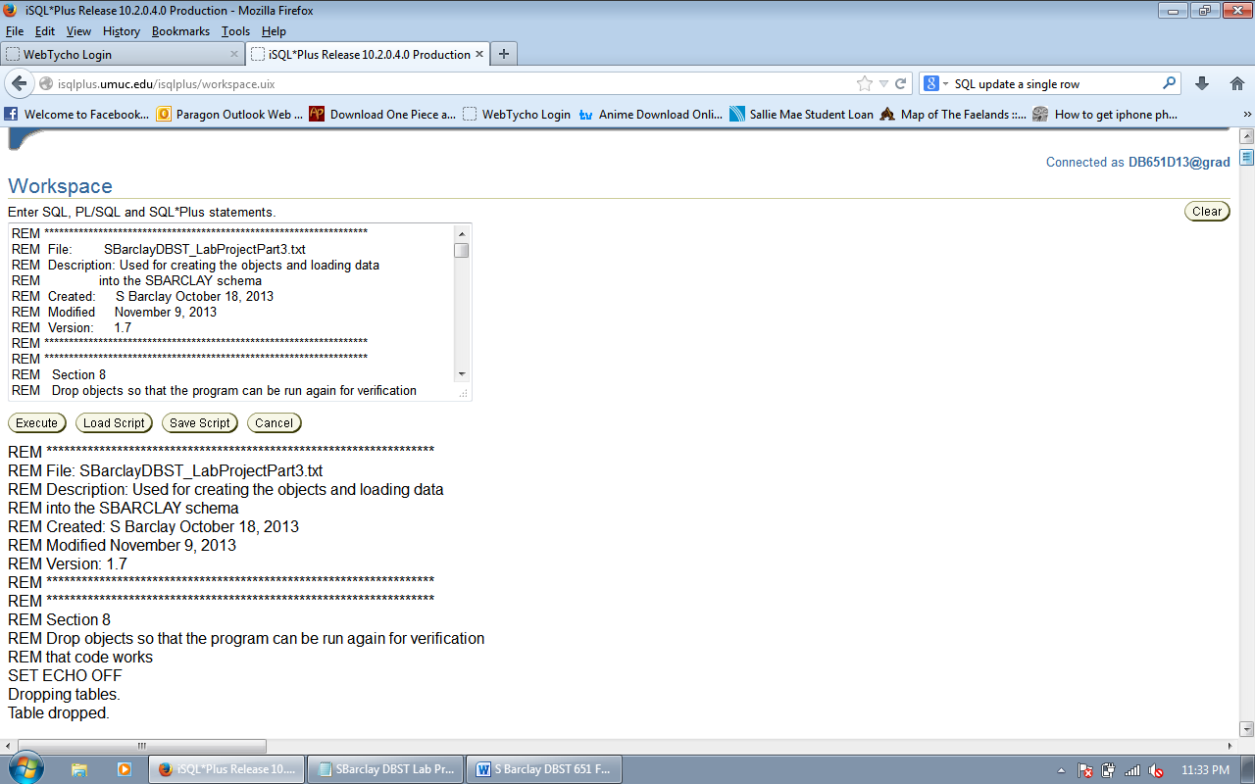

Confirmation that previous information was dropped
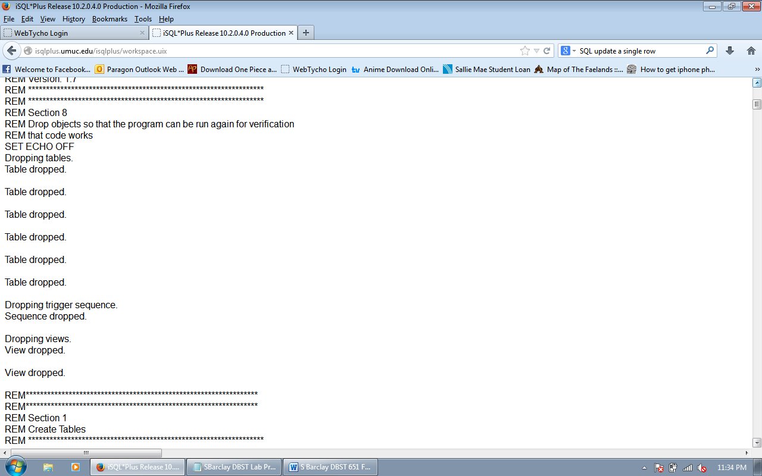

Creating tables
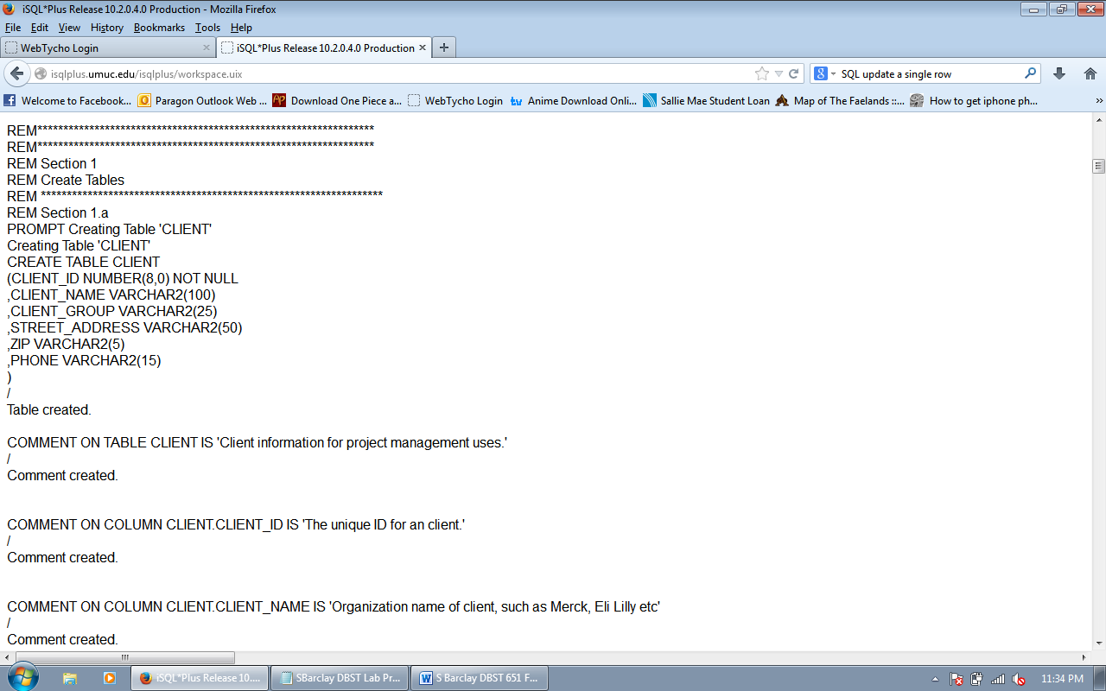

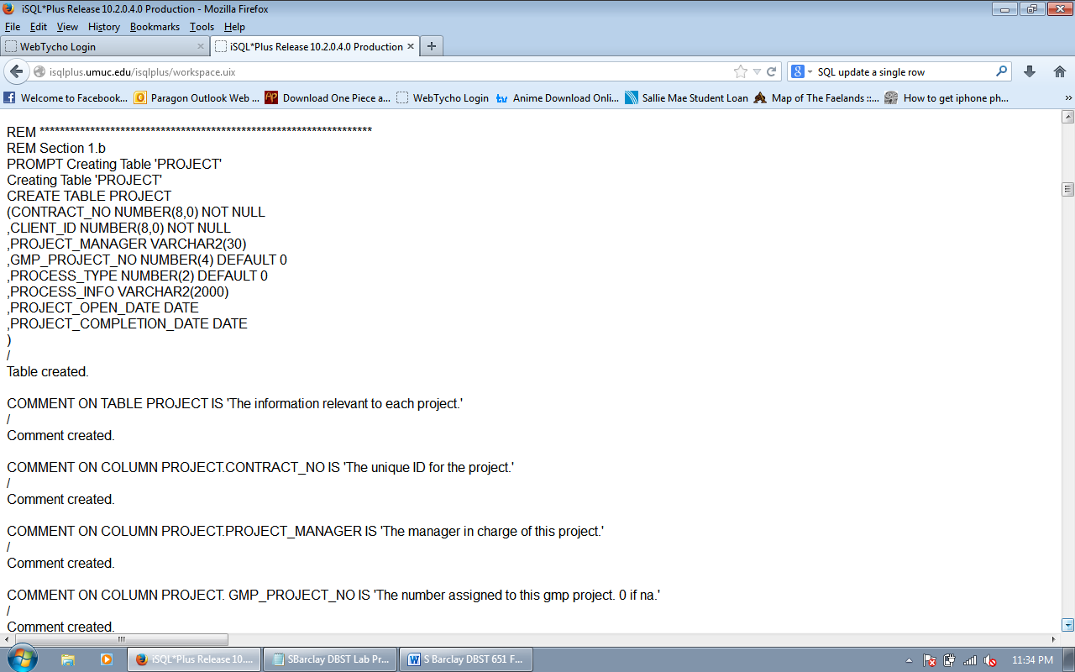

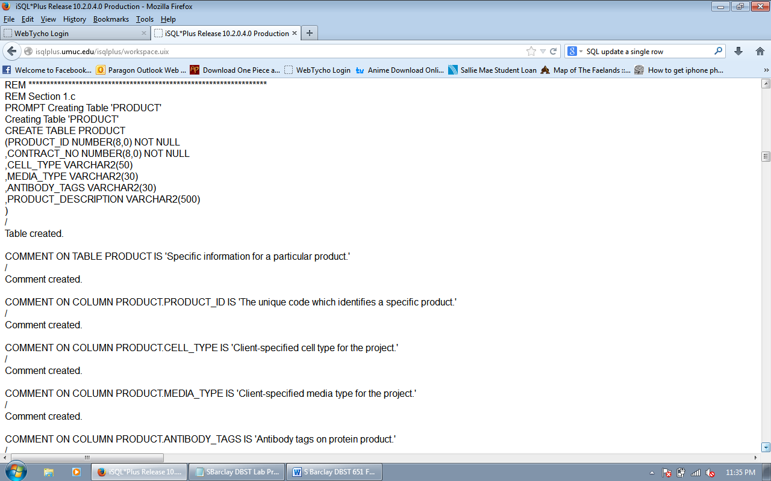

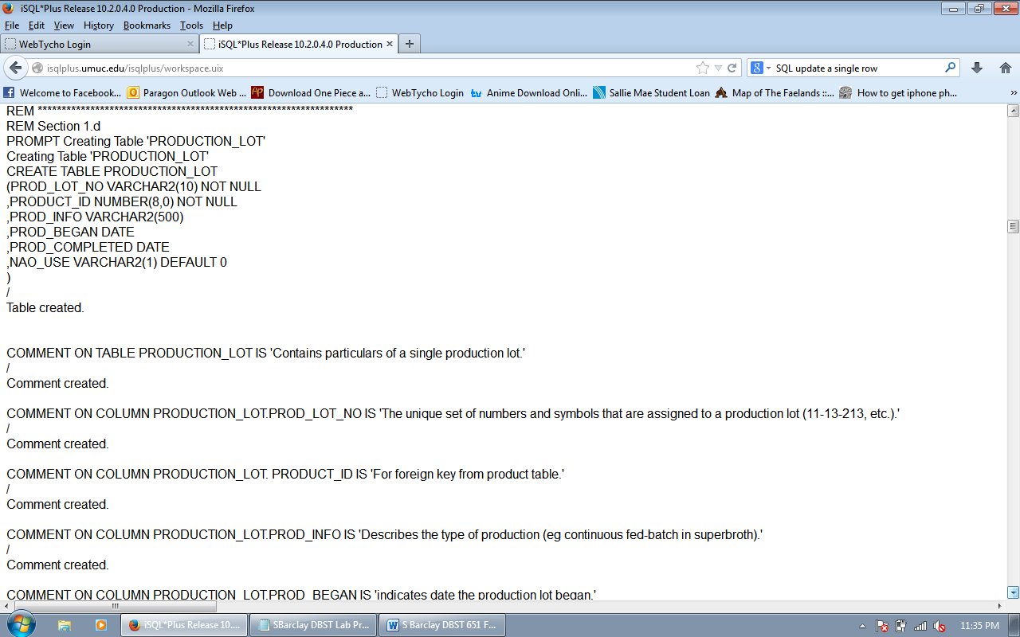

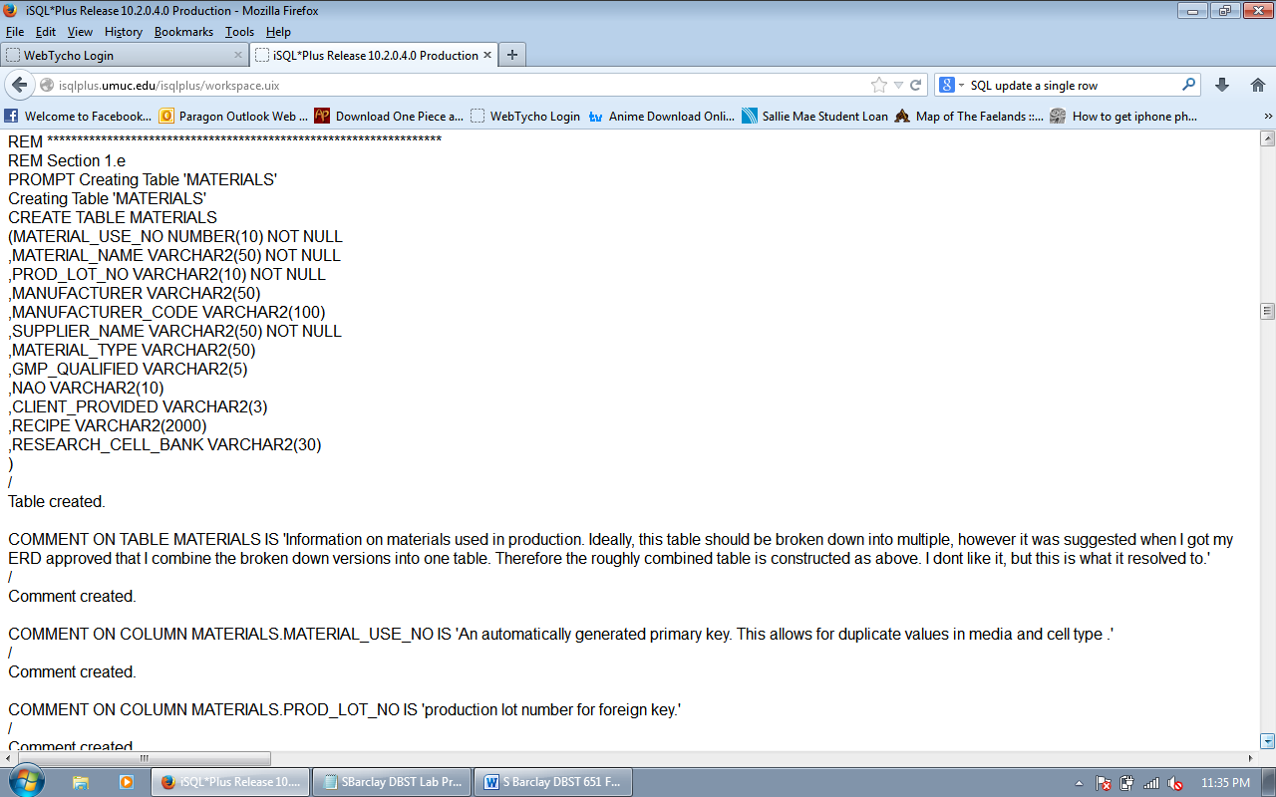

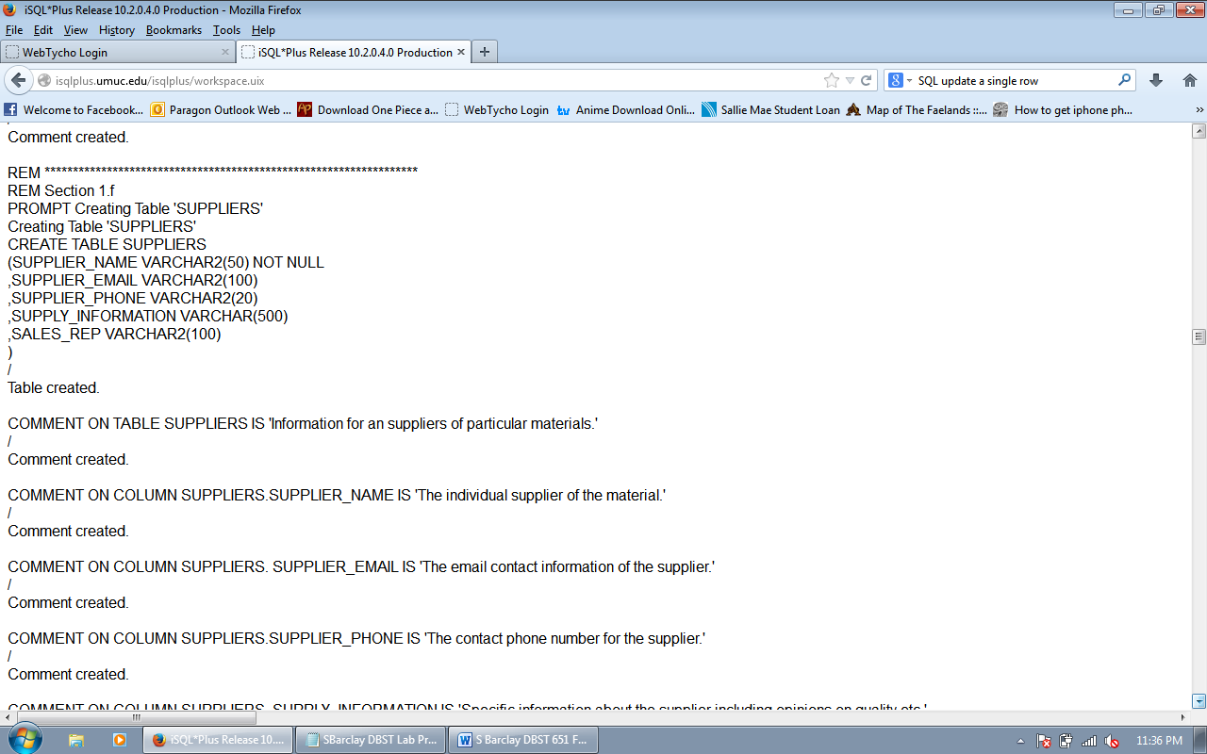

Index foreign keys
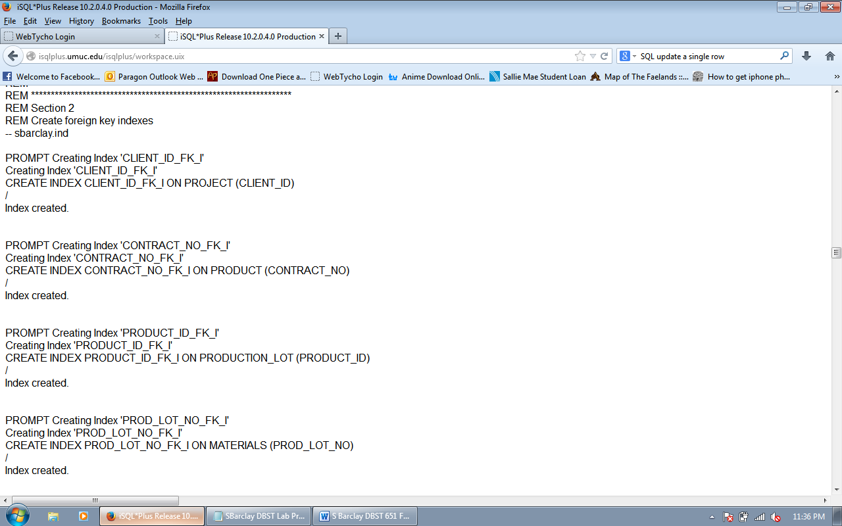

Create trigger for material use number
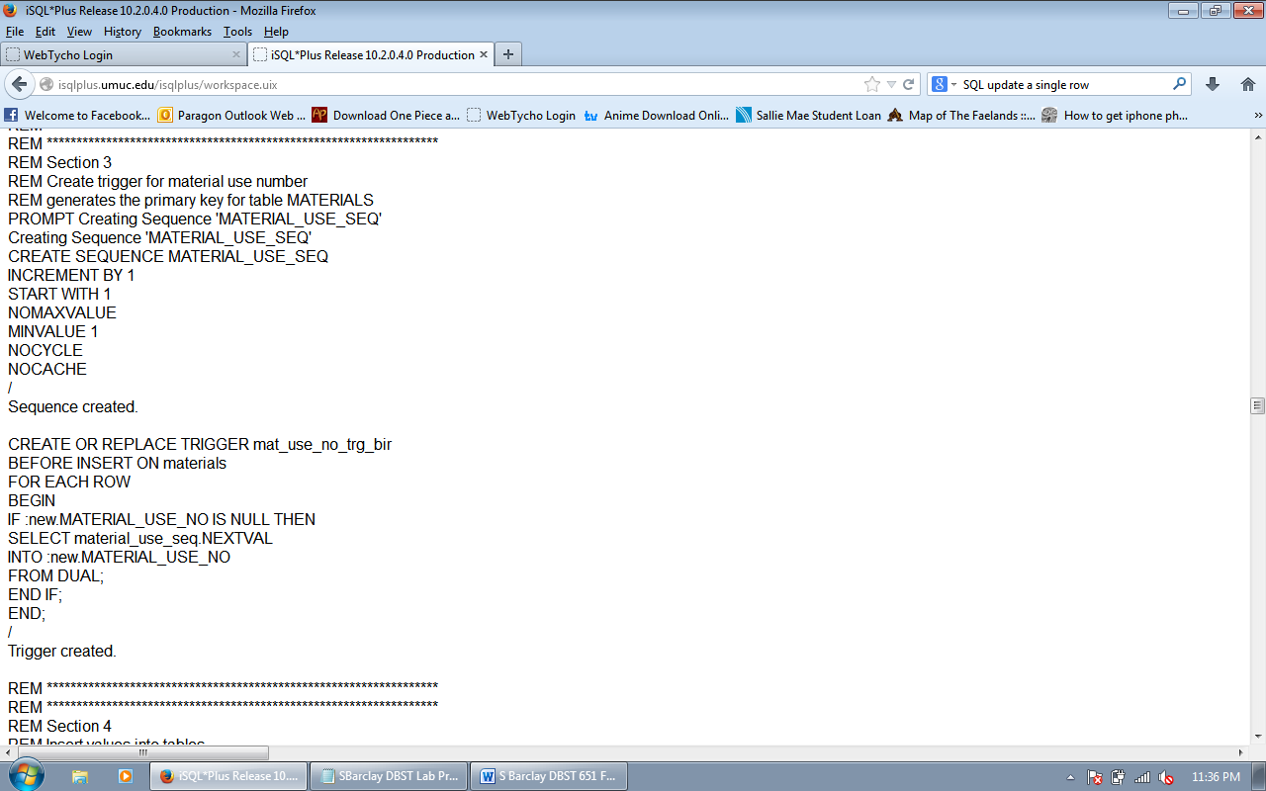

Insert data into client table

Insert data into project table
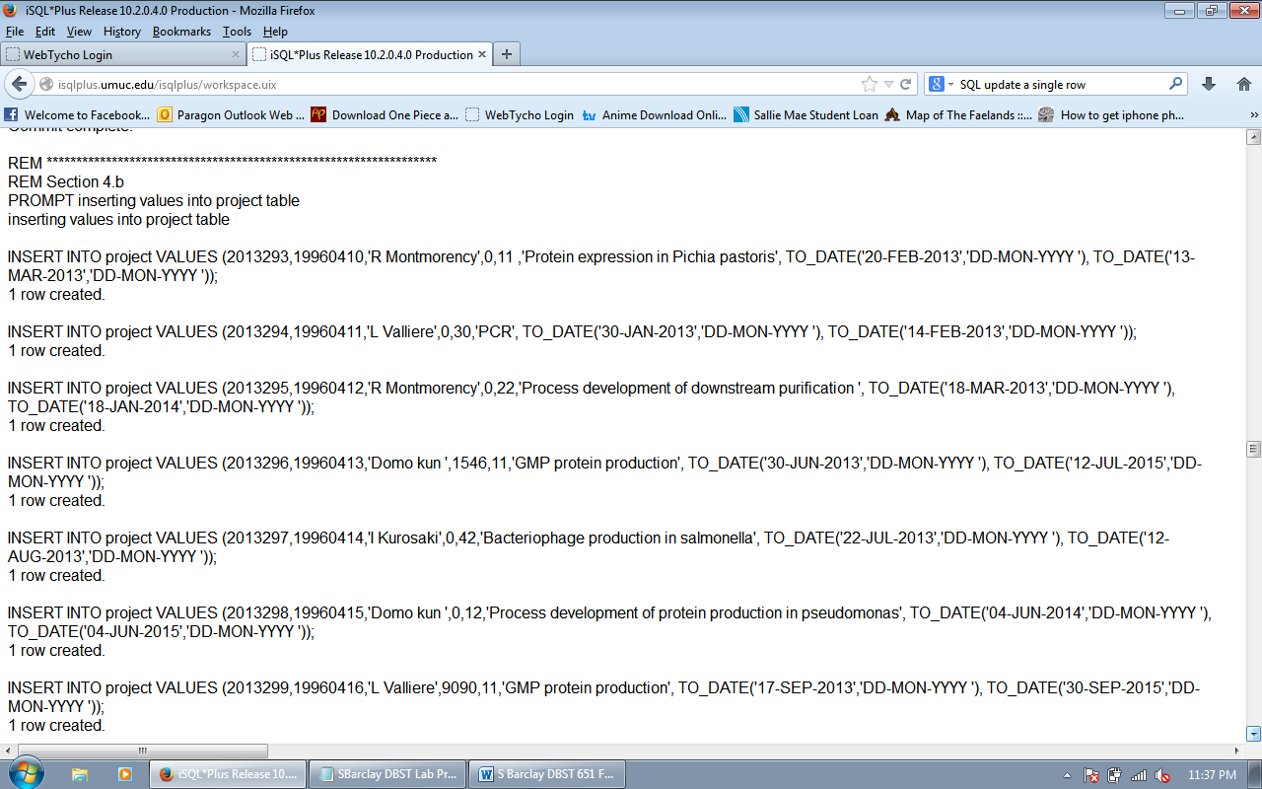

Insert data into product table
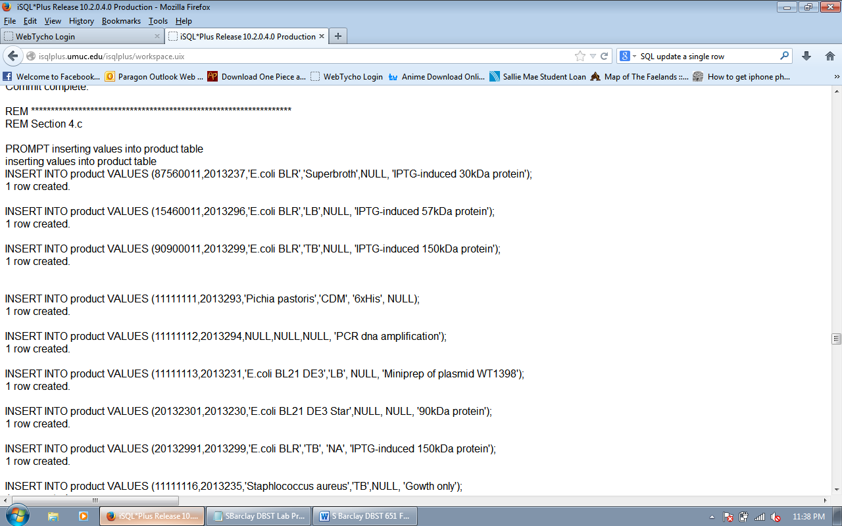

Insert data into production lot table
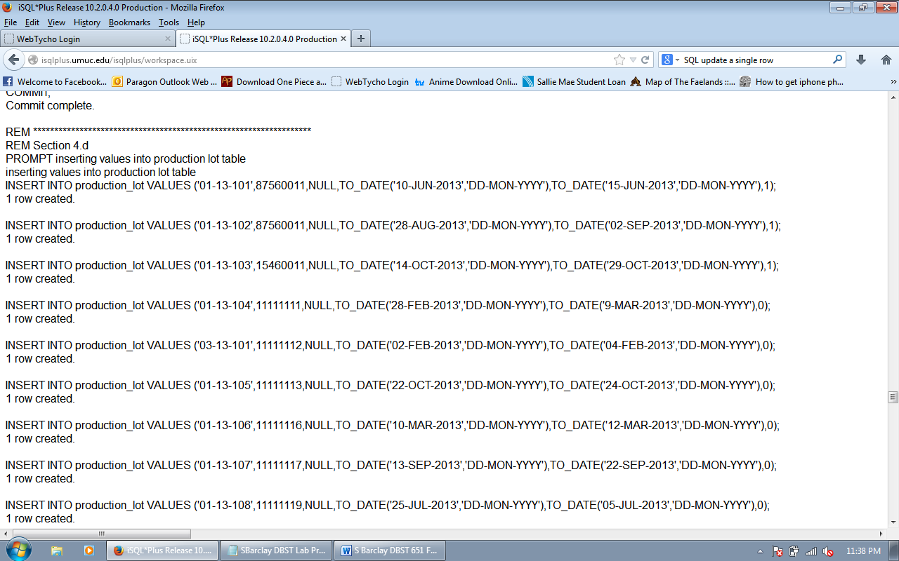

Insert data into materials table
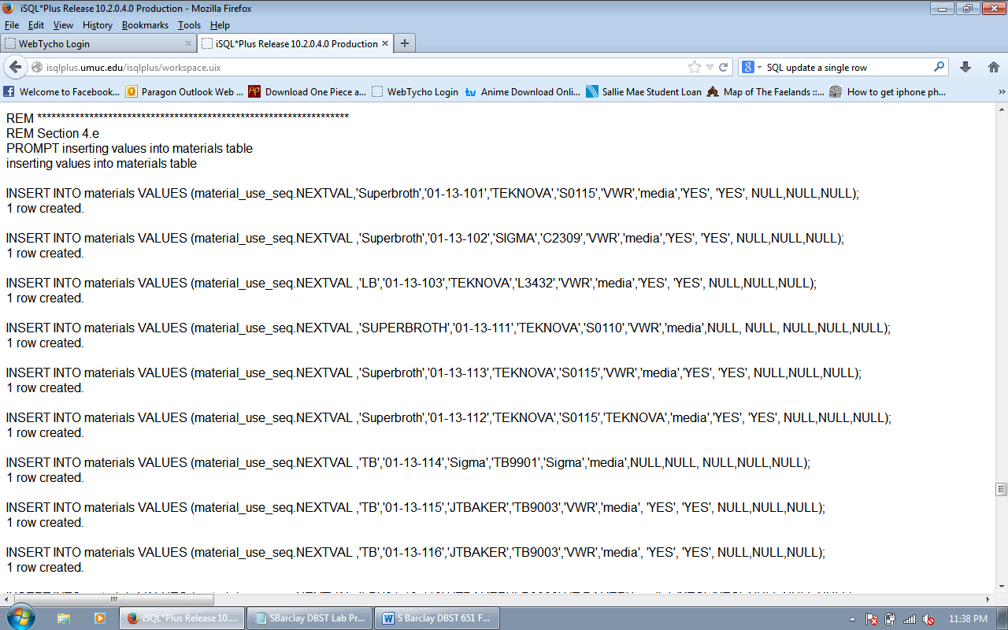

Insert data into suppliers table
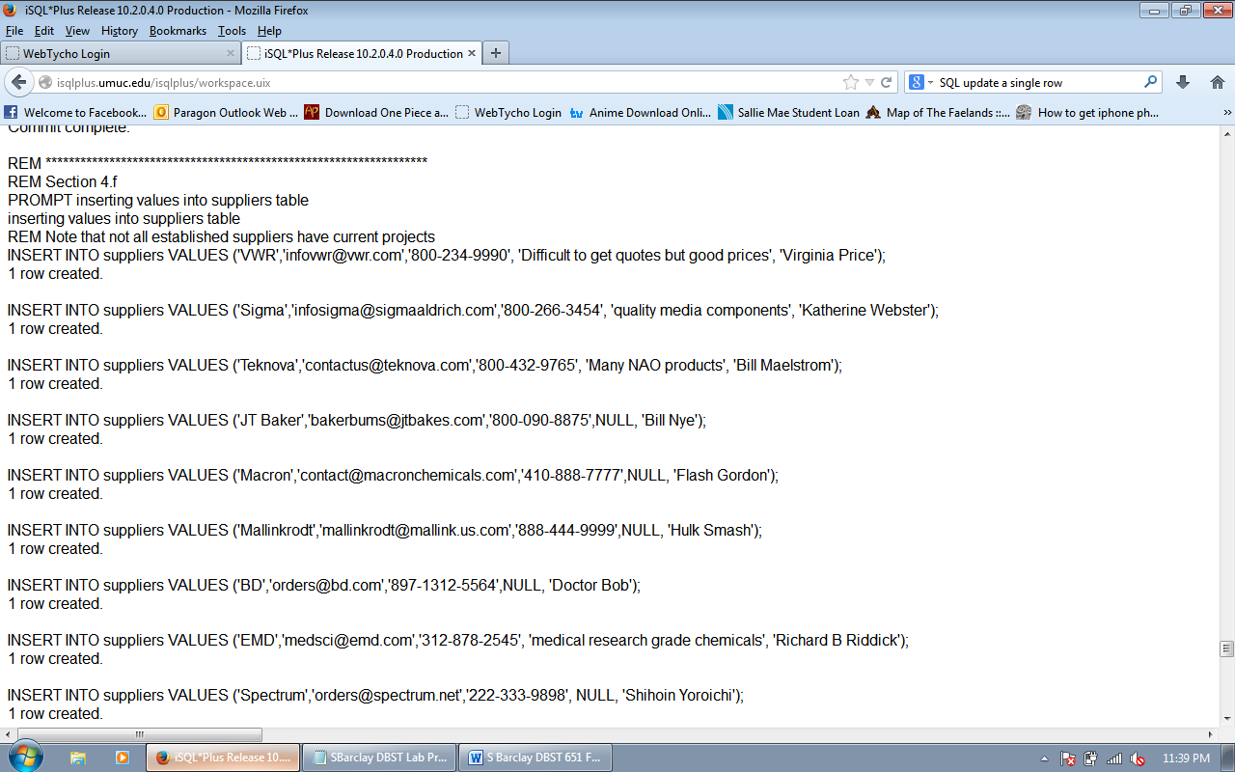

Create primary keys
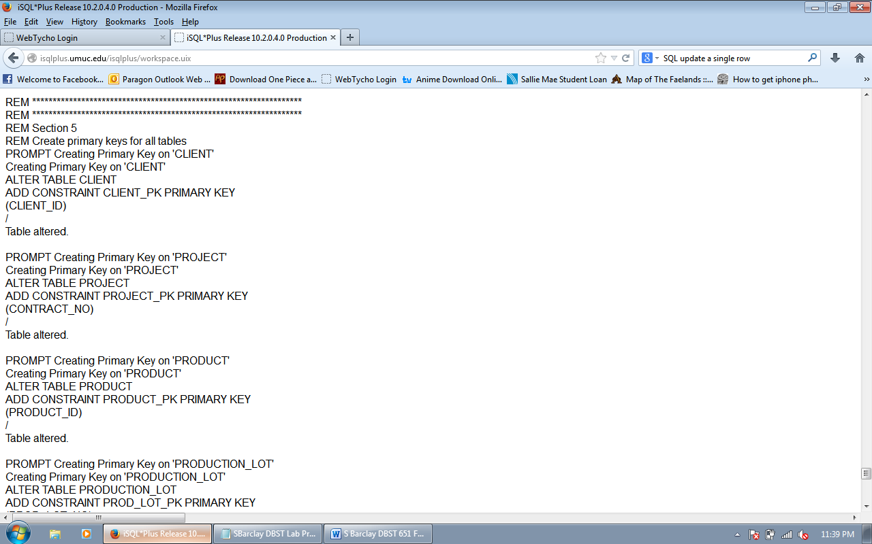

Verify entity creation
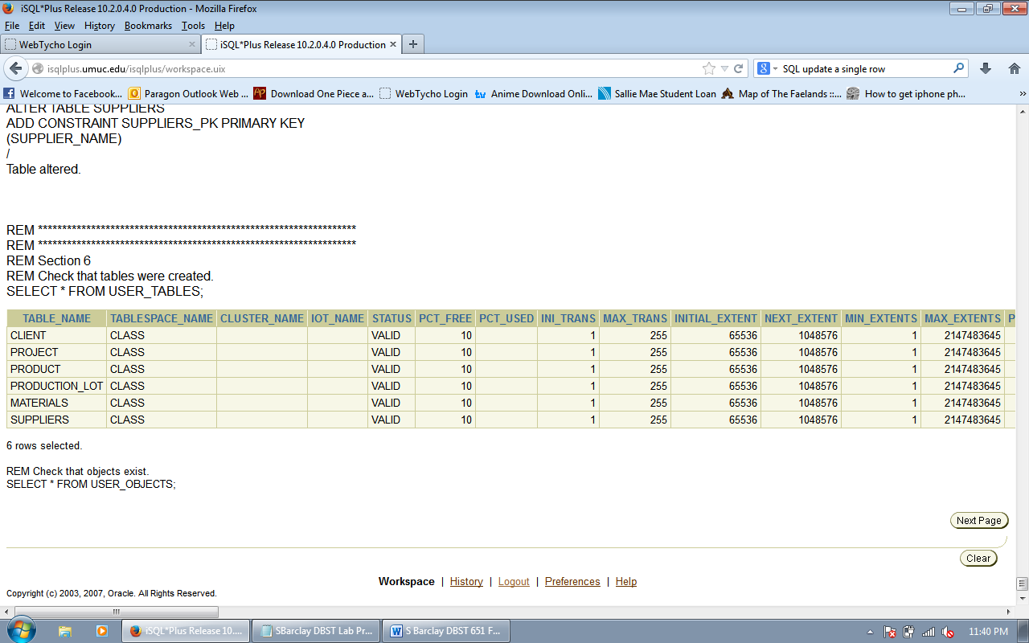

Verify objects were created
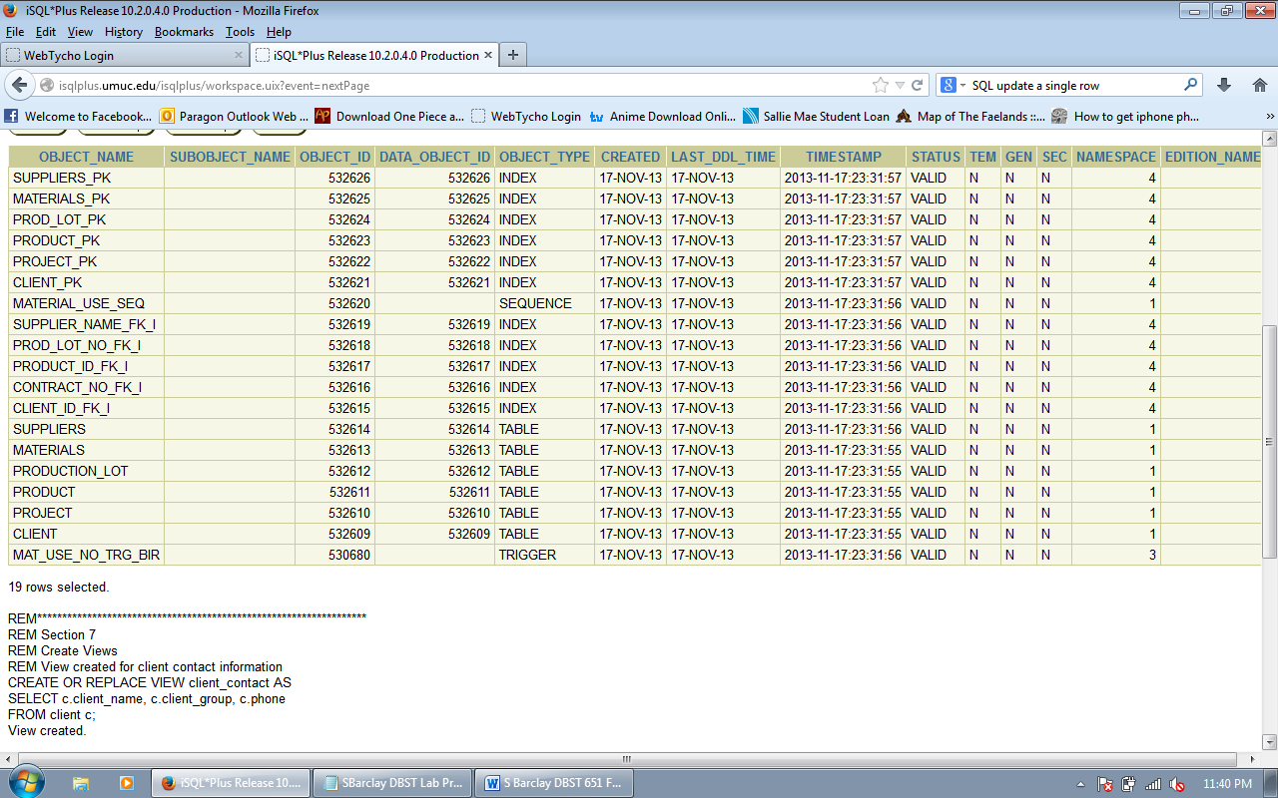

Create view and begin select statements
